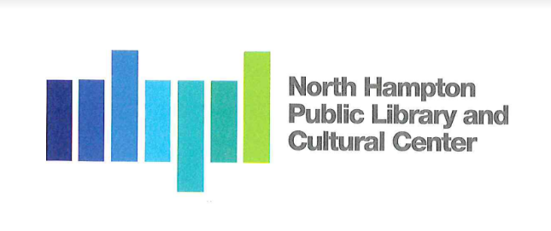
North Hampton Public Library - Board of Trustees

Public Meeting Minutes
North Hampton Town Hall
231 Atlantic Ave
Tuesday, October 18, 2022
5:30 PM

Chair: Jacqueline Brandt Library Director: Susan Grant
Treasurer: Kathleen Kilgore Assistant Director: Liz Herold
Secretary: Susan Leonardi
______________________________________________________________________

- Call to Order by the Chair Call to order 5:32pm
  - Pledge of Alliance

- Facilities Update
George Chauncey continues to work with BPS on joint caulking repair with Bonnette, Page, and Stone. During last week’s windy, rainy day, water leaked from the Alden Avenue and Patio doors. BPS discovered it was a caulking issue. BPS will repair it. One of the carpet squares has lifted. George will adhere the corner to the floor again. He will call the sprinkler company to schedule winterizing of the irrigation system.

3. Administrative
3.1. Approval of Meeting Minutes. Jacquie Brandt motion to approve. Susan seconded. All approve.
3.2. Library Reports. Library Director Susan Grant presented reports. Jacqui Brandt motion to approve. Susan seconded. All approve.

4. Old Business
4.1. Director’s Review Schedule Non-public Meeting. On Tuesday, November 1, at 6:00 pm, we will have the review in the Reading Room at North Hampton Public Library.
4.2. Annual Celebration- Review. Food and desserts are from Joe’s Meat Shop. Max Sullivan will be performing in the back lounge area.
4.3. Landscape committee meeting. Jacqui Brandt will ask the committee if they can meet with us at the next regular meeting.
4.4. Mural –completed. Community members and library visitors have well received Sam Malpass’s mural. Dana Hooper from the NHPL CC contacted Storywall to install and design the acrylic blocks with the donor names. We look forward to having her finish the panel on the adjacent wall.

- New Business

5.1. Invoice review. No new invoices to review.
5.2. Proposed purchases. No upcoming purchases to discuss at this meeting.

- Any Other Item that may legally come before the Board; The Board reserves the right to act on any item relative to the prudential administration of the library’s affairs, which circumstances may require.

- NHDPW -Hub spoke to George about sharing storage space in a shed located somewhere in the future once the public safety meeting.

- Kathy Kilgore noted that the Budget Committee presentation would be on October 31. We agree that we will highlight the Library usage and youth statistics to justify full-time benefits for the Youth Librarian. Kathy Kilgore motioned to approve the proposed budget as of October 13, 2022, for the fiscal year 2024 and submit it to the Budget Committee. Jacqui Brandt seconded the motion. All approved.

- Library Project Review. We are looking at the week of November 16th-19th for a scheduled annual review of the project with Lavallee Brensinger Architects.

- Next Meeting/Adjournment. 6:13pm

