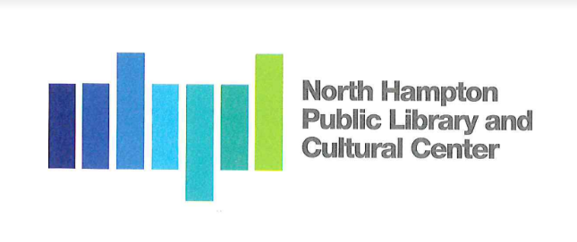
North Hampton Public Library - Board of Trustees
Meeting Minutes

Notice of Public Meeting
At North Hampton Public Library
239 Atlantic Ave
Monday, November 22, 2021
6:00 PM

Chair: Susan Leonardi
Treasurer: Jacqueline Brandt
Secretary: Kathleen Kilgore
Alternate: Emily Creighton

Library Director: Susan Grant
______________________________________________________________________

- Call to Order by the Chair
The Chair opens the meeting at 6:09 pm

  - Pledge of Allegiance
All in attendance recite the Pledge of Allegiance

- Old Business
  - Budget Committee presentation recap
The Board discusses the meeting with the Budget Committee on November 22, 2021, and confirms that we are confident with the bottom line number of the budget we presented. The Board is scheduled to meet with the Budget Committee again on Monday, December 6, 2021.

  - Windows/Shades and Blinds
The Board reviews the different samples of blinds provided by Portsmouth Blind and Shade Company. Board asks that Director to follow up to verify whether the blinds are all motorized or are there chains.

Motion: I make a motion that we accept the proposal from Portsmouth Blind and Shade Company dated November 9, 2021, for $ 19,500.00 finished and installed. The selections picked by the Board are:
Light blocking shade in White Platinum
Sunblock shade in Blue Denim
Shade block to be 5%
Made By: Jacqui Brandt
Seconded By: Kathleen Kilgore
Vote: 3-0

- New Business
  - Holiday party
The Board discusses holding a holiday party for the staff. The Director confirms that The Seacoast Academy of Music is having two holiday concerts, December 5th and December 12th. She mentions that there is a lot going on and it is always a challenge to choose a day that everyone can attend. The Director mentions the seacoast librarian hold a festivist the first week of January each year. The Board decides to hold a Yankee swap with a holiday party in January.

  - LBA invoice

Made By: Kathleen Kilgore
Seconded By: Jacqui Brant
Vote: 3-0

  - Marketing Brochure
The Chair briefs the Board on the progress of the marketing brochure for the community. Susan Leonardi has been using the map that Kirsten put together and
adding more context. Elissa commented that the Librarians need to give input and material. The brochure is going to be a guide in the form of a newsletter. The Friends of the North Hampton Public Library is going to pay for the brochure. We are looking at a cost of $ 3,000.00 - $ 5,000.00. This is just an estimate the Board has not officially approved a price yet. Susan Leonardi has asked a hard deadline for mailing by December 10th. The consensus of the Board is to wait until after the holidays, mailing to the community in January.

  - Discontinue use of 237A Atlantic Avenue.

- Any Other Item that may legally come before the Board
The Board reserves the right to act on any item relative to the prudential administration of the Library’s affairs, which circumstances may require.

