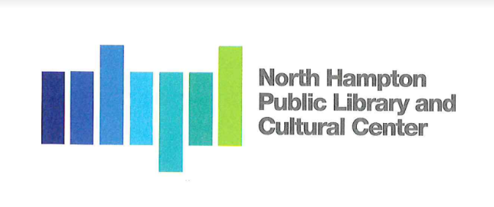
North Hampton Public Library - Board of Trustees
Meeting Minutes

Notice of Public Meeting
At North Hampton Public Library
237A Atlantic Ave
Wednesday, September 28, 2021, 4:30 pm

Attendees:

Chair: Susan Leonardi
Treasurer: Jacqueline Brandt
Secretary: Kathleen Kilgore
Alternate: Emily Creighton

Marketing Coordinator (Contracted): Kirsten Larsen Schultz, Marketing Ally
____________________________________________________________________________________

- Call to Order by the Chair at 4:35 pm
  - All in attendance recite the Pledge Allegiance.

- New Business
  - Bonnett, Page & Stone Requisition 12 & 13

Motion: I make a motion that we approve Bonnett, Page & Stone’s Payment Application
No 12 dated August 23, 2021, for $ 112,431.04. the source of the payment to be the Bond Proceeds as authorized in 2020 March Warrant Article #8.
Made by: Kathleen Kilgore
Second by: Jacqui Brandt
Vote: 3-0

Motion: I make a motion that we approve Bonnett, Page & Stone’s Payment Application
No 13 dated September 24, 2021, for $ 37,255.15 the source of the payment to be the Library Capital Reserve Fund.
Made by: Kathleen Kilgore
Second by: Jacqui Brandt
Vote: 3-0
2.2 Grand Opening
The Board reviews the NHPL Grand Opening Checklist
NHBA has ceremonial scissors to lend
Kirsten Larsen Schultz will contact Mary Beth Driscoll at school to send a flyer out in the Friday Folders this week and next week. Kristen will also reach out to, Evonne, Chair of Pal, and Jan Facella to add to the Town’s Friday Folders this week and next week.

Kathleen Kilgore and Kirsten Larsen Schultz will review list of Town Departments and Boards to identify the appropriate contact for each to send invitations to.

Kathleen Kilgore will invite John Savastano & Channel 22 team.

Kirsten Larsen Schultz will invite appropriate NHBA Board members and members.

Susan Leonardi with pull a list of past Trustees.

Jacqui Brandt will take the action item of personally inviting the neighbors.

Kirsten Larsen Schultz has designed the welcome banner. The Board chose the second design and have instructed Kristen to order the banner.

Emily Creighton will secure the ribbon for the ribbon cutting ceremony

Susan Leonardi will research option for Name Tags

We should dig out the ornaments of the original library to sell.

Emily Creighton will craft the invitation to be used by the Trustees

- Old Business
  - NHPL FY2022 Budget
The Board reviewed the latest changes to the budget which incorporated the changes identified at the Board’s meeting on September 16, 2021, and additional changes after Kathleen Kilgore spoke with the Town’s Finance Director.

Motion: I make the FY2023 Budget as presented tonight.
Made by: Susan Leonardi
Second by: Jacqui Brandt
Vote: 3-0

  - Meeting Room Policy – The Board table further discussion on the policy until Susan Grant could be in attendance to discuss in detail the suggested changes to the policy received from Town Counsel.

- Any Other Item that may legally come before the Board

- Next Meeting / Adjournment

Susan Leonardi, the Chair closes the meeting at 6:30 pm

Minutes by Recording Secretary: Kathleen Kilgore

Approved:

