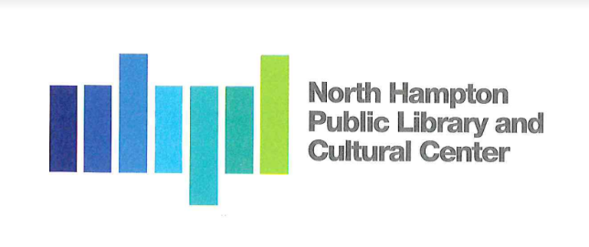
North Hampton Public Library - Board of Trustees
Meeting Agenda

Notice of Public Work Session
Public Zoom Meeting Only through North Hampton Public Library
237A Atlantic Ave
Thursday, November 19, 2020
6:30 PM

Chair: Kathleen Kilgore
Treasurer: Susan Leonardi
Secretary: Jacqueline Brandt
Alternate: Emily Creighton
Director: Susan Grant
Assistant Director: Liz Herold

Guests: North Hampton Public Library & Cultural Center Foundation
Ron Lamarre, LaValle Brensinger Architects
______________________________________________________________________
In following CDC, State and Federal recommendations for social distancing the Board of Trustees is holding a Public Meeting via Zoom. There will be no physical public locations for actual meeting. The Public may attend by Zoom meeting connection.

Board members and Presenters will have the ability to participate by Zoom in the meeting.

- Call to Order by the Chair and Pledge of Allegiance

- New Business

  - North Hampton Public Library & Cultural Center Foundation Fundraising for New Library

- Any Other Item that may legally come before the Board
The Board reserves the right to take action on any item relative to the prudential administration of the
Library’s affairs, which circumstances my require.

- Next Meeting / Adjournment

ZOOM Meeting Participation Information

Topic: Library Trustees
Time: Nov 19, 2020 06:30 PM Eastern Time (US and Canada)
Join Zoom Meeting
https://us02web.zoom.us/j/82402403157
Meeting ID: 824 0240 3157
One tap mobile
+13017158592,,82402403157# US (Washington D.C)
+13126266799,,82402403157# US (Chicago)
Dial by your location
+1 301 715 8592 US (Washington D.C)
+1 312 626 6799 US (Chicago)
+1 646 876 9923 US (New York)
+1 669 900 6833 US (San Jose)
+1 253 215 8782 US (Tacoma)
+1 346 248 7799 US (Houston)
+1 408 638 0968 US (San Jose)
Meeting ID: 824 0240 3157
Find your local number: https://us02web.zoom.us/u/kuDCiuBhe

