Librarian’s Report
June 5, 2019
Susan Grant, Director

Operations
- Window screens keep coming out. Public Works has taken them off to put new screens in.
- We are getting the outside sign repaired and cleaned by Timberline Signs who designed and installed it – provided by the Friends of the Library.
- North Hampton Public Library is an affiliate library partner with Familysearch.org that brings millions of genealogical records to researchers online to those with an account, which is free and accessible anywhere a computer and internet access is available. However, some records are not accessible at home due to restrictions placed by those who own the records but allowed Familysearch to microfilm and digitize them. Those records can be viewed at NHPL because we are an affiliate, or can be viewed at a Family History Center. Familysearch has now added the ability for affiliate libraries to create Wikis as a tool to make people aware of our library as a location where records can be accessed that are unavailable through their account at home.
- Elissa von Letkemman who designed our logo is designing a bumper sticker for us using a design guide given her at a cost of $75 and printing costs. It will look similar to this in an oval shape-
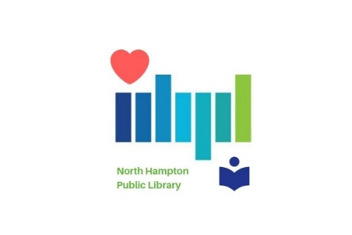

Financial
- Operating Account reconciled ending balance 5/31/2019 TDBank $47,083.00
- Non-appropriated Funds Account TDBank reconciled ending balance 4/30/2019 $84,470.21
- Peoples Bank CD#1 142,312.34 (plus any interest accrued)
- Peoples Bank CD#2 $94,874.90 (plus any interest accrued)
- Peoples Bank Checking Account $10,064.45 (May statement not received yet)
- Capital Reserve Fund as of 5/31/2019 $340,994.63.
- Received a $500 donation to the library from Tibbie Field.

Statistics
Waiting for statistics from some vendors to complete the month. Overall materials circulation was slightly up from last month. Overall circulation is higher this year than last year.
- We signed up 32 kindergarteners from NHS and 13 adults in May.
- There were 7 new Overdrive users.

Staff
- Susan attended the NHLTA conference May 29th in Manchester.
- Staff met with Ron Lamarre of Lavallee Brensinger Architects to designate interior spaces in the renovation/addition. Updated floor plan is available to view. This is not the final version, but one more step in the design process.

Programs
- NH Humanities program: Stark Decency: New Hampshire’s WWII German Prisoner of War Camp. Rescheduled for Sept 17th at 7 pm.
- Read to a dog (kids) R.E.A.D. to Rover program has been post-poned. Tucker had an accident at home and is recovering.
- June 4th 6:30 pm Harmonica Workshop with Mike Rogers was cancelled due to lack of interest.
- July 23rd 6:30 pm - Cruising NH History: A Guide to New Hampshire’s Roadside Historical Markers – Michael Bruno talk about his experience and book.
- July 26th 2 pm Friday Flick will be Squalus a documentary with Karen Raynes, journalist hosting
- July 31st 2:30 pm Medicare 101 by ServiceLink rep.
- Aug 8th 6 pm How to sell on eBay. Workshop by Robbin Levin.
- Sept 26th 6:30 pm Nature of New Hampshire, a Speaking for Wildlife program
- Oct 2nd 6:30 Pilgrims of Woodstock, John Kane who wrote a book and put together a program commemorating the 50th anniversary of Woodstock.
- Oct 17th 6:30 pm Quotable Eleanor Roosevelt with author Michele Albion
- Oct 24th 6:30 pm Spirit Chasers – 3rd year presenting a “spirited” program at NHPL.
- Nov 5th 6:30 pm Stephen Collins will present Herman Melville in a literary program/performance entitled Sailing Towards My Father. Stephen Collins has performed as Robert Frost and Walt Whitman in past years at the library.
- Nov 12 – Aileen Kelly, Living History reenactor will present a historical program about women in the military.
- Nov 14th Mt. Kearsarge Museum Travel Program focuses on Native Americans.
Upcoming……
- Tick talk - a program about ticks and pets which is being planned by the Dog Park Committee and will be cohosted by the library.

